Bangladesh Medical Association (BMA)
List of Life Member-41
56. BMA Rangamati Branch

Sl No | Voter No | Voter Details
1 | Voter No  LM-5600001  No Image | DR. MD. MOSTAFIZUR RAHMAN  F/Name:  M/Name:  BM & DC Reg. No:  NID:  Cell:  Address:  Blood Group:
2 | Voter No  LM-5600002  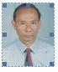 | DR. UDAY SHANKAR DEWAN  F/Name: Late. Biraj Mohan Dewan  M/Name:  BM & DC Reg. No:  NID:  Cell: 01558884989  Address: Civil Surgeon.  Blood Group:
3 | Voter No  LM-5600003  No Image | DR. TAPAN KUMAR CHAKRABORTY  F/Name: Late Niranjan Chakraborty  M/Name:  BM & DC Reg. No:  NID:  Cell:  Address: Medical Officer, Clinic  Blood Group:  E X P I R E D
4 | Voter No  LM-5600004  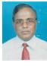 | DR. MD. NAZER  F/Name: Late Hazi Abdul Karim  M/Name:  BM & DC Reg. No:  NID:  Cell: 017131658506  Address: Ex-Civil Surgeon,  Rangamati.  Blood Group:
5 | Voter No  LM-5600005  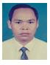 | DR. SNEHA KANTI CHAKMA  F/Name: Nayan Kumar Chakma  M/Name:  BM & DC Reg. No:  NID:  Cell: 01715191373  Address: Upazilla H & FP Office  Rangamati Sadar, Rangamati.  Blood Group:
6 | Voter No  LM-5600006  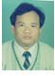 | DR. NILO KUMAR TANCHANGYA  F/Name: Laksmi Kumar Tanchangya  M/Name:  BM & DC Reg. No:  NID:  Cell: 01819675743  Address: North Kalindi Pur  Rangamati.  Blood Group:
7 | Voter No  LM-5600007  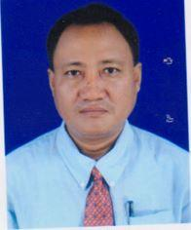 | DR. SUSHOBHAN DEWAN  F/Name: Mr. Mihir Kanti Dewan  M/Name: Late. Sadhana Chakma  BM & DC Reg. No: 22638  NID: 8428703118062  Cell: 01715086183  Address: Tribal Officers Colony, Sadar, Rangamati,  Blood Group: B+
8 | Voter No  LM-5600008 | DR. KETI CHAKMA  F/Name: Sunirmol Chakma  M/Name: Kamalika Chakma  BM & DC Reg. No: 32338  NID: 8428708147961  Cell: 01730349429  Address: General Hospital Road, North Kalindipur, Rangamati, Katwali. Rangamati  Blood Group: O+
9 | Voter No  LM-5600008  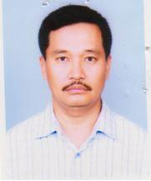 | DR. PARSH KHISA  F/Name: Bhagadatta Khisa  M/Name:  BM & DC Reg. No:  NID:  Cell: 01556702529  Address: North Kalindipur, Rangamati.  Blood Group:
10 | Voter No  LM-5600009  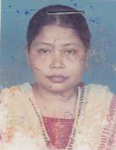 | DR. BABY TRIPURA  F/Name: Late. Chitta Raonjan Tripura  M/Name: Late. Nirmola Tripura  BM & DC Reg. No: 22960  NID: 8428703194542  Cell: 01556534992  Address: Kala Pahar Area, Rangamati  Blood Group: B+
11 | Voter No  LM-5600010  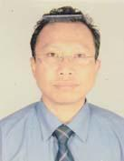 | DR. LENIN TALUKDER  F/Name: Kiran Chandra Talukder  M/Name: Sharna Protima  BM & DC Reg. No: 29498  NID: 4624907153272  Cell: 01920796358  Address: Doctors Quarter, Mother & Child Weliedcomplex  Blood Group: O+
12 | Voter No  LM-5600011  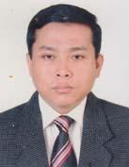 | DR. BIPASH KHISA  F/Name: Late. Birendra Lal Khisa  M/Name: Mrs. Prava Rani Chakma  BM & DC Reg. No: 23185  NID: 8428704120813  Cell: 01817706554  Address: Medical Officer, Office Of The UH & FPO, Sadar Upazilla, Rangamati.  Blood Group: O+
13 | Voter No  LM-5600012  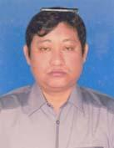 | DR. JIBAK CHAKMA  F/Name: Late. Hriday Ranjan Chakma  M/Name: Late. Parul Chakma  BM & DC Reg. No: 30082  NID: 8428708147039  Cell: 01199277531  Address: College Gate, Montree Para, Rangamati Sadar, Rangamati Hill Tvacts  Blood Group:
14 | Voter No  LM-5600013  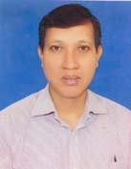 | DR. AMAL CHAKMA  F/Name: Late. Chitta Ranjan Chakma  M/Name: Usha Rani Chakma  BM & DC Reg. No: 22412  NID: 8428703115006  Cell: 01715098367  Address: Medical Officer, General Hospital, Rangamati  Blood Group: AB_po
15 | Voter No  LM-5600014 | DR. ALSTOY CHAKMA  F/Name: Late. Satya Brata Chakma  M/Name: Late. Sashi Bala Chakma  BM & DC Reg. No: 25729  NID: 8428703194600  Cell: 01816889112  Address: Anaesthesia Department, Chittagong Medical College Hospital, Chittagong  Blood Group: B+
16 | Voter No  LM-5600015 | DR. ASHISH KUMAR TANCHANGYA  F/Name: Mr. Rabi Mohan Tanchangya  M/Name: Mrs. Joylia  BM & DC Reg. No: 40513  NID: 8428708146319  Cell: 01550608145  Address: MO, Bilaichari Upazilla Health Complex, Rangamati .  Blood Group: A+
17 | Voter No  LM-5600016  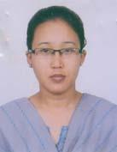 | DR. CHUSUNG CHING MARMA  F/Name: Mr. Sanu Bai Marma  M/Name: Late. Sacraing Marma  BM & DC Reg. No: 47549  NID: 8413676361720  Cell: 01711811487  Address: Vill: Narangiri Mukh, P.O: Raikhali bazar, PS: Chandroghona, Dist: Rangamati  Blood Group: A+
18 | Voter No  LM-5600017  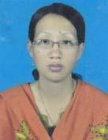 | DR. UTPAL BARNA CHAKMA  F/Name: Monindra Lal Chakma  M/Name: Ujjala Chakma  BM & DC Reg. No: 40177  NID: 8428708148640  Cell: 01820347234  Address: Roaya Bhavon, South Kalindipur, Rangamati Sadar, Rangamati  Blood Group: O+
19 | Voter No  LM-5600018  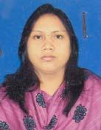 | DR. HLAMARHEE  F/Name: Maung Ching Maung  M/Name: Chowsan  BM & DC Reg. No: 43741  NID: 2694814971171  Cell: 01552741842  Address: Baghaichari Upazilla Health Complex  Blood Group: A+
20 | Voter No  LM-5600019  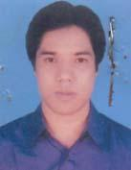 | DR. AVIJIT CHOWDHURY  F/Name: Prabhudan Chowdhury  M/Name: Aloka Chowdhury  BM & DC Reg. No: 49939  NID: 1926718125645  Cell: 01833358062  Address: Medical Officer, Betaichari Upazilla Health Complex, Rangamati  Blood Group: O-
21 | Voter No  LM-5600020  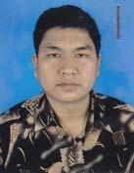 | DR. KYAW YANG CHAK  F/Name: Mong Mong Chak  M/Name: Swihlamee Chak  BM & DC Reg. No: 40178  NID: 8428708148661  Cell: 01711983187  Address: Roaza Bhabon, South Kalin Lipur, Rangamati.  Blood Group: O+
22 | Voter No  LM-5600021  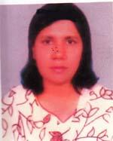 | DR. HENA RANI BARUA  F/Name: Prauat Chandra Barua  M/Name: Prativa Barua  BM & DC Reg. No: 18204  NID: 2694263699159  Cell: 01731493609  Address: Mayani, Abutorab, Mirsarai, chittagonj  Blood Group: B+
23 | Voter No  LM-5600022  No Image | N/A  F/Name:  M/Name:  BM & DC Reg. No:  NID:  Cell:  Address:  Blood Group:  E X P I R E D
24 | Voter No  LM-5600023  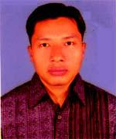 | Dr. Joydhan Tanchangya  F/Name: Sneha Kumar Tanchangya  M/Name: Banu Tanchangya  BM & DC Reg. No: 45990  NID: 8413686371456  Cell: 01714408933  Address: Vill: Debatachari, Baroichari, Kaptai, Rangamati  Blood Group: A+
25 | Voter No  LM-5600024  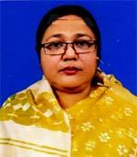 | DR. RUHI BANANI  F/Name: Dr. Moyez Uddin Sarkar  M/Name: Jahanara Begum  BM & DC Reg. No: 21445  NID: 2617278007688  Cell: 01711445670  Address: UHC & FPO, Rangamati Sadar, Rangmati  Blood Group: B+
26 | Voter No  LM-5600025  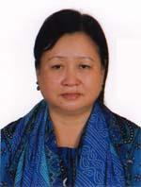 | DR. SWEEMIPRUE ROAZA  F/Name: Chaithowai Rozaza  M/Name: Snehamaye Chakma  BM & DC Reg. No: 28165  NID: 8428709158352  Cell: 01753347906  Address: C/O Ananda Chakma House Debashis Nagar, Rangamati  Blood Group: B+
27 | Voter No  LM-5600026  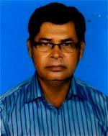 | DR. MD. IBRAHIM  F/Name: Hajee Abdul Gofur  M/Name: Maharun Nessa  BM & DC Reg. No: 16197  NID: 8428702113133  Cell: 01557400155  Address: Reserve Bazar, Mosjid Colony, Rangamati  Blood Group: O+
28 | Voter No  LM-5600027  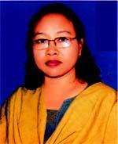 | DR. HELEN CHAKMA  F/Name: Late. Buddhi Dwip Chakma  M/Name: Biroja Chakma  BM & DC Reg. No: 28397  NID: 8428705127673  Cell: 01820329646  Address: Kallayanpur Road, Rangamati  Blood Group: O+
29 | Voter No  LM-5600028 | DR. KETI CHAKMA  F/Name: Sunirmol Chakma  M/Name: Kamalika Chakma  BM & DC Reg. No: 32338  NID: 8428708147961  Cell: 01730349429  Address: Rangamati Kotowali Rangamati.  Blood Group:
30 | Voter No  LM-5600029 | DR. DIPANKAR TANCHANGYA  F/Name: Mohan Lal Tanchangya  M/Name: Jyosna Chakma  BM & DC Reg. No: 40148  NID: 6430874013  Cell: 01552506923  Address: College Gate, Rangamati  Blood Group: B+
31 | Voter No  LM-5600030  No Image | DR. TANITA DEWAN  F/Name: Jnana Bin Dewan  M/Name: Mena Chakma  BM & DC Reg. No: 49195  NID: 2726403123104  Cell: 01828866603  Address: P.O: Tabal Chari (Majher Bosti) P.S: Kotwali District: Rangamati.  Blood Group: AB+
32 | Voter No  LM-5600031  No Image | DR. RASHMI CHAKMA  F/Name: Jahat Jyoti Chakma  M/Name: Manjurika Chakma  BM & DC Reg. No: 53665  NID: 2924709173634  Cell: 01715056950  Address: West Tribal Adam, Rangamati.  Blood Group: B+
33 | Voter No  LM-5600032  No Image | DR. ACHINU MAUNG  F/Name: Bacchu Maung  M/Name: Bungma  BM & DC Reg. No: 89428  NID: 8687143167  Cell: 01552717257  Address: Majher Bosti, Tabalchari, Rangamati.  Blood Group: B+
34 | Voter No  LM-5600033  No Image | DR. GOURAB DEWAN  F/Name: Animesh Dewan  M/Name: Sudipta Dewan  BM & DC Reg. No: 37989  NID: 8428708151269  Cell: 01712599770  Address: Bijon Sarani, Vill- Kalindipur, P.O: Rangamati, P.S: Kotowali, Dist: Rangamati.  Blood Group: O+
35 | Voter No  LM-5600034  No Image | DR. SUPRIYA BARUA  F/Name: Sudhangshu Bimal Barua  M/Name: Sagar Prabha Barua  BM & DC Reg. No: 2752  NID: 7303630789  Cell: 01830038606  Address: K.K Roy Road P.S: Kotwali P.O: Rangamati, 4500. Rangamati.  Blood Group: O+
36 | Voter No  LM-5600035  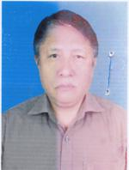 | DR. NITISH CHAKMA  F/Name: Late: Tarun Kanti Chakma  M/Name: Tuni Bala Chakma  BM & DC Reg. No: 21862  NID:  Cell: 01556569106  Address: Civil Surgeon Office, Rangamati.  Blood Group: B+
37 | Voter No  LM-5600036  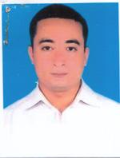 | DR. USAMAUNG MARMA  F/Name: Chingcha Prue Marma  M/Name: Lili Marma  BM & DC Reg. No: 47220  NID: 19824798516226924  Cell: 01712998113  Address: South Kalindipur, Sadar Upazilla, Rangamati.  Blood Group: A+
38 | Voter No  LM-5600037  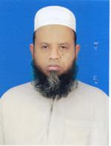 | DR. M.A HEYE  F/Name: Ramij Uddin Molla  M/Name: Fatema Begom  BM & DC Reg. No: 22607  NID: 19661916765000014  Cell: 01675507326  Address: General Hospital, Rangamati, Hill District.  Blood Group: B+
39 | Voter No  LM-5600038  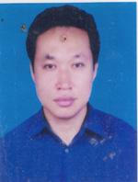 | DR. NUYAN KHISA  F/Name: Chandra Shekhar Khisa  M/Name: Charumoti Khisa  BM & DC Reg. No: 37702  NID: 8428703117974  Cell: 01554301766  Address: UH & FPO, Baghaichari UHC, Baghaichari, Rangamati.  Blood Group: B+
40 | Voter No  LM-5600039  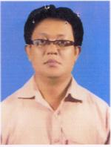 | DR. MAUNG KYAW THEIN  F/Name: Mr. Aung Maung  M/Name: Mrs. Uhla Ching  BM & DC Reg. No: 28870  NID: 19728428703115039  Cell: 01820315598  Address: Kata Pahar, Tabal Chari Rangamati Hill Traeti.  Blood Group: B+
41 | Voter No  LM-5600040  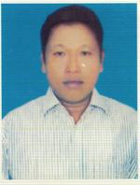 | DR. SAMAR SEN TRIPURA  F/Name: Late: Gobinda Lal Tripura  M/Name: Late: Kusumika Tripura  BM & DC Reg. No: 52589  NID: 6125201101032  Cell: 01555031977  Address: Kalayanpur, Rangamati Sadar, Rangamati Hill Tract.  Blood Group: A+

